Name: Nonfiction: Summarizing – Q2:2 Date:
As you answer this week’s questions, highlight your evidence in the text.
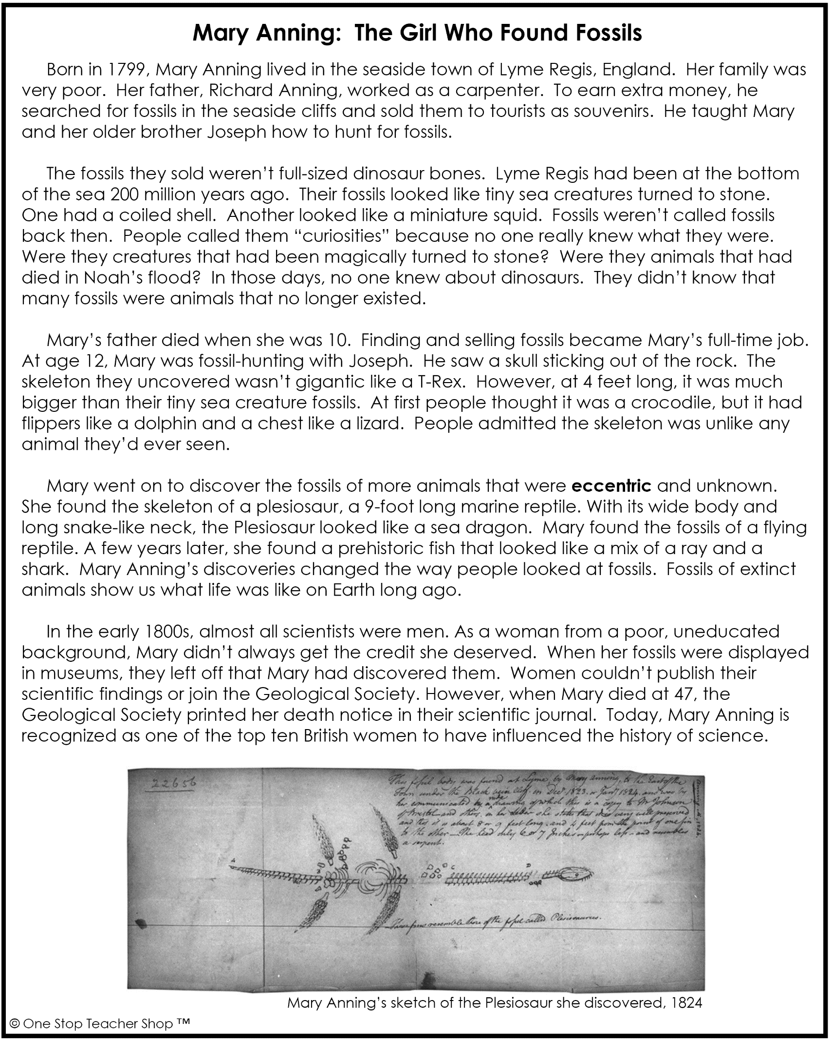
Nonfiction: Summarizing – Q2:2
Monday | Tuesday
What is this text mostly about?  ___________________________________________ | Describe the fossils Mary and her brother were used to finding?  ___________________________________________
What skill did Mary’s father teach her and her brother?  ___________________________________________ | Based on the third paragraph, how was this fossil different from other fossils Mary had found?  ___________________________________________
Why did the fossils of Lyme Regis look like tiny sea creatures?  ___________________________________________ | Based on the text, what is the meaning of the word eccentric?  ___________________________________________
According to the text, why were fossils called “curiosities”?  ___________________________________________ | Although he died when Mary was 10, how did Mary’s dad influence her future?  ___________________________________________
Wednesday | Thursday
What creature did the author compare to a Plesiosaur?  ___________________________________________ | Write a short summary about this text.  _____________________________________________________________________________________________________________________________________________________________________________________________________________________________________________________________________________________________________________  ___________________________________________
Based on the fourth paragraph, what was the effect of Mary finding so many unusual and new fossils?

___________________________________________
According to the text, why didn’t Mary get the credit she deserved as a scientist?

___________________________________________
What can we learn from fossils of extinct animals?

___________________________________________

More of My Thinking
Monday | Tuesday
__________________________________________________________________________________________________________________________________________________________________________________________________________________________________________________________________ | __________________________________________________________________________________________________________________________________________________________________________________________________________________________________________________________________
Wednesday | Thursday
__________________________________________________________________________________________________________________________________________________________________________________________________________________________________________________________________ | __________________________________________________________________________________________________________________________________________________________________________________________________________________________________________________________________

My Progress
MONDAY  _____ out of 4 correct  I need more help with…  _____________________  _____________________  _____________________ | TUESDAY  _____ out of 4 correct  I need more help with…  _____________________  _____________________  _____________________ | WEDNESDAY  _____ out of 4 correct  I need more help with…  _____________________  _____________________  _____________________ | THURSDAY  _____ out of 4 correct  I need more help with…  _____________________  _____________________  _____________________
Answer Key - Nonfiction: Summarizing – Q2:2
Monday | Tuesday
What is this text mostly about?  Accept all reasonable answers. | Describe the fossils Mary and her brother were used to finding?  Small sea creatures
What skill did Mary’s father teach her and her brother?  He taught them how to hunt for fossils. | Based on the third paragraph, how was this fossil different from other fossils Mary had found?  This fossil was much bigger than other fossils they had found.
Why did the fossils of Lyme Regis look like tiny sea creatures?  Lyme Regis had been at the bottom of the sea 200 million years ago. | Based on the text, what is the meaning of the word eccentric?  different or strange
According to the text, why were fossils called “curiosities”?  People called them “curiosities” because no one really knew what they were. | Although he died when Mary was 10, how did Mary’s dad influence her future?  Because he taught her how to hunt for fossils, she ended up making a career out of it.
Wednesday | Thursday
What creature did the author compare to a Plesiosaur?  A sea dragon | Write a short summary about this text.  Accept all reasonable answers.
Based on the fourth paragraph, what was the effect of Mary finding so many unusual and new fossils?

She changed the way people looked at fossils.
According to the text, why didn’t Mary get the credit she deserved as a scientist?

Because she was a woman from a poor and uneducated background.
What can we learn from fossils of extinct animals?

Fossils of extinct animals show us what life was like on Earth long ago.

