Name: Fiction: Summarize – Q2:2 Date:
As you answer this week’s questions, highlight your evidence in the text.
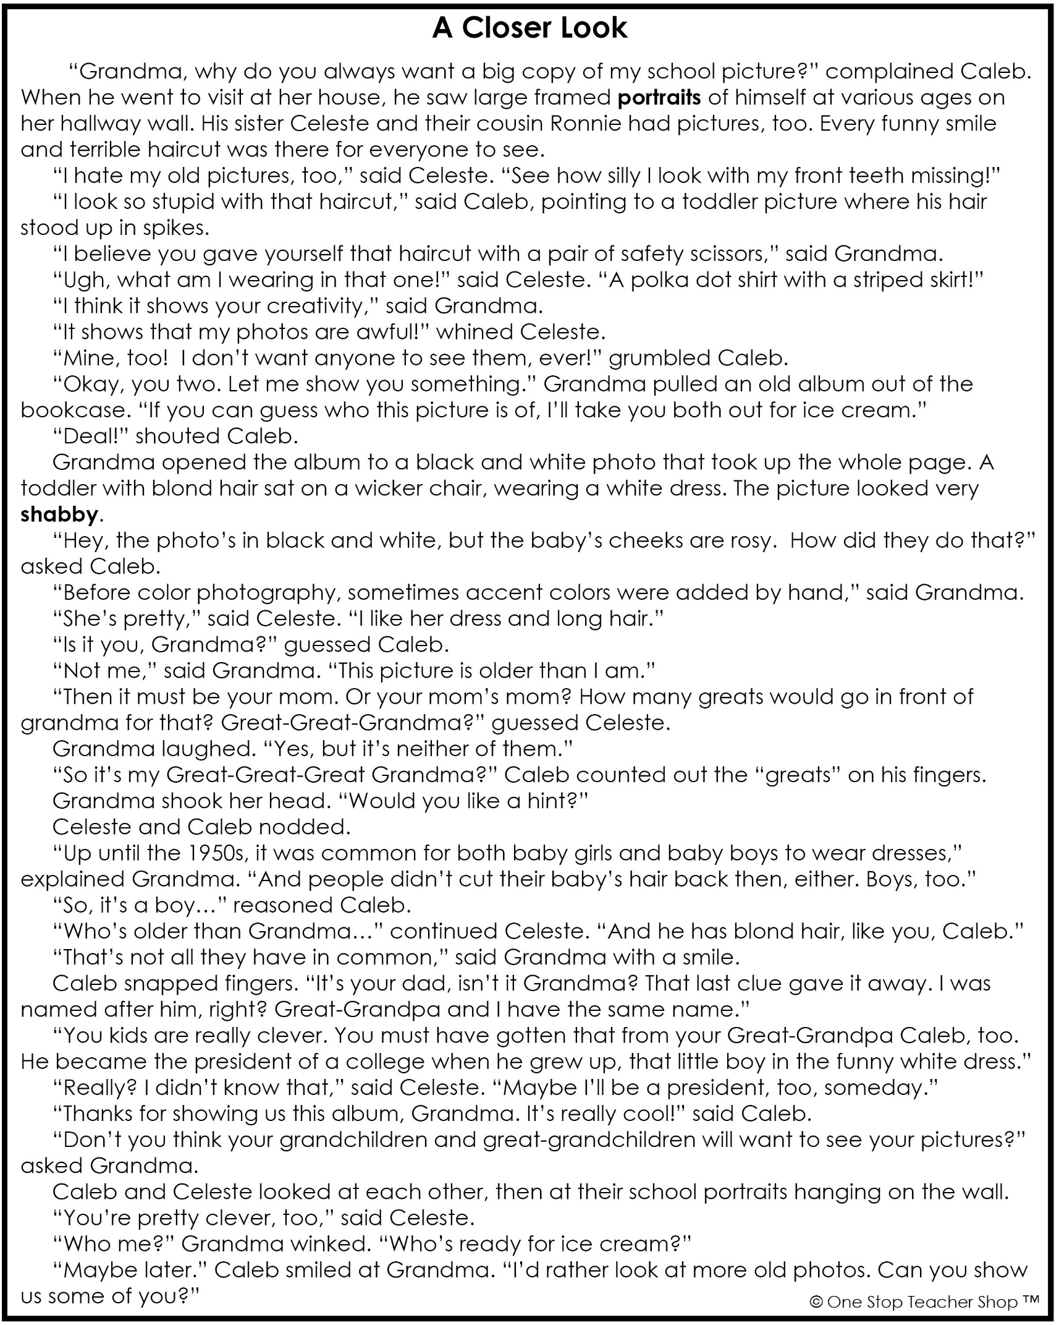

Fiction: Summarize – Q2:2
Monday | Tuesday
Where does this story take place?  ___________________________________________ | When Caleb complains about his pictures, what does his Grandma do?  ___________________________________________
Who are the characters in the story?  ___________________________________________ | How do Caleb and Celeste feel about their portraits? Support your answer.  ___________________________________________
What might be another good title for this story?  ___________________________________________ | Why would showing Caleb and Celeste the old photo make them feel better?  ___________________________________________
Determine the meaning of the word portraits in the story.  ___________________________________________ | Who was the baby in the picture?  ___________________________________________
Wednesday | Thursday
According to the story, why might Caleb have thought the baby in the old picture was a girl?  ___________________________________________ | Write a short summary about this story.  _____________________________________________________________________________________________________________________________________________________________________________________________________________________________________________________________________________________________________________  ___________________________________________
What lesson was Grandma trying to teach Caleb and Celeste?

___________________________________________
Determine the meaning of the word shabby in the story.

___________________________________________
How did Caleb feel when he found out his Great-Grandpa was president of a college?

___________________________________________
Wh
More of My Thinking
Monday | Tuesday
__________________________________________________________________________________________________________________________________________________________________________________________________________________________________________________________________ | __________________________________________________________________________________________________________________________________________________________________________________________________________________________________________________________________
Wednesday | Thursday
__________________________________________________________________________________________________________________________________________________________________________________________________________________________________________________________________ | __________________________________________________________________________________________________________________________________________________________________________________________________________________________________________________________________

My Progress
MONDAY  _____ out of 4 correct  I need more help with…  _____________________  _____________________  _____________________ | TUESDAY  _____ out of 4 correct  I need more help with…  _____________________  _____________________  _____________________ | WEDNESDAY  _____ out of 4 correct  I need more help with…  _____________________  _____________________  _____________________ | THURSDAY  _____ out of 4 correct  I need more help with…  _____________________  _____________________  _____________________
Answer Key - Fiction: Summarize – Q2:2
Monday | Tuesday
Where does this story take place?  At Grandma’s house | When Caleb complains about his pictures, what does his Grandma do?  She shows him an old picture.
Who are the characters in the story?  Caleb, Celeste, Grandma | How do Caleb and Celeste feel about their portraits? Support your answer.  They don’t like them; they say they dislike their hair, teeth, smile, etc.
What might be another good title for this story?  Accept all reasonable answers. | Why would showing Caleb and Celeste the old photo make them feel better?  They can see that everyone has pictures they don’t like.
Determine the meaning of the word portraits in the story.  a picture of someone | Who was the baby in the picture?  Caleb’s Great-Grandpa
Wednesday | Thursday
According to the story, why might Caleb have thought the baby in the old picture was a girl?  Back then, it was common for baby boys to wear dresses and have longer hair. | Write a short summary about this story.  Accept all reasonable answers.
What lesson was Grandma trying to teach Caleb and Celeste?

Pictures are important for future generations. Everyone has pictures they don’t like.
Determine the meaning of the word shabby in the story.

old; worn
How did Caleb feel when he found out his Great-Grandpa was president of a college?

He felt he could be president too.

