Accessing the Science Textbook online at home!
*Disclaimer* The pictures provided are from a 4th grade book, please select the corresponding grade level your student needs. The steps are the same for all grade levels!

- Go to launchpad.fultonschools.org. You need to go to Class Link

- You should see the following, students know how to sign in using their lunch code as the username and their birthday as the password. Please email your child’s teacher if you need this information.

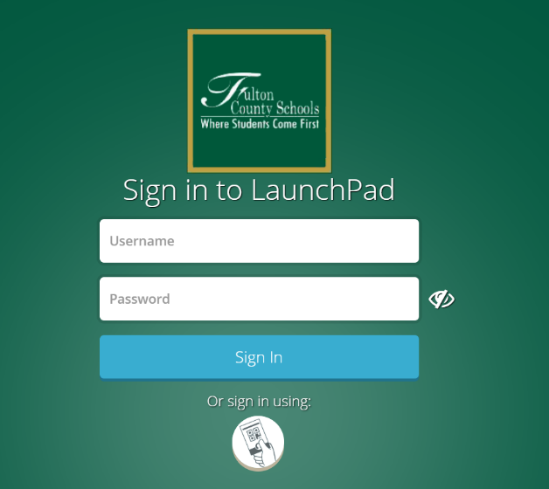

- Once logged on click on the following icon, McGraw Hill.
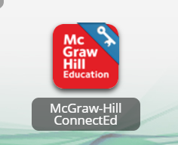

- Once you have clicked on the icon, you will see different book options to click on. Locate the following book that corresponds with your child’s grade level as it may be a different color than the 4th grade textbook.

- After clicking on the correct book, you will see the following “home screen” for science resources.
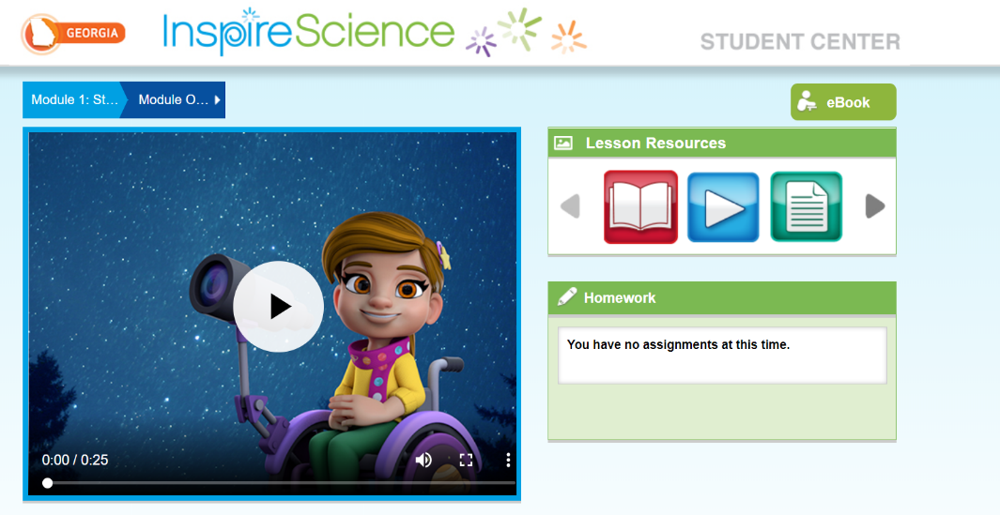

- In the top, right corner you will see a search bar to type in. Type in “Handbook”.

- After searching for the handbook, the following results will appear.
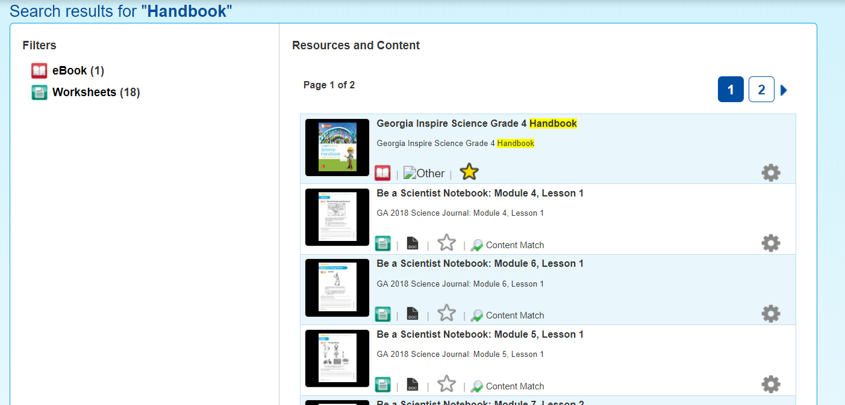

- Click on the first option to locate the Science Textbook, make sure your options of book say the correct grade level needed.
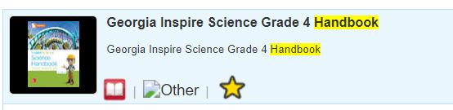

- After clicking on the “Georgia Inspire Science Grade ___ Handbook” you will see the cover of the book, use tools to navigate through the entire textbook.
